Azure DevOps and Monitoring
Agenda
- Azure DevOps
- Core Services of Azure DevOps
- CI/CD
- CI/CD Pipelines
- Azure Monitoring and Log Analytics
- Azure Load Balancer
Azure DevOps:
DevOps is a set of practices, cultural philosophies, and tools that aim to bridge the gap between software development (Dev) and IT operations (Ops). The goal is to enhance collaboration, automation, and efficiency throughout the software development lifecycle (SDLC) and to enable continuous integration (CI) and continuous delivery (CD).
Key Features of DevOps:
- Automation – Automating manual tasks in software development and deployment.
- Collaboration – Breaking silos between Dev and Ops teams.
- Continuous Integration & Continuous Deployment (CI/CD) – Ensuring code changes are automatically built, tested, and deployed.
- Monitoring & Feedback – Using real-time data to improve processes.
Why to use Azure for DevOp:
Azure DevOps provides a full suite of tools to manage the software lifecycle, including:
1. Integrated toolchain – Everything from version control to deployment.2. Cloud-based – No need to set up servers for CI/CD.3. Security & Compliance – Secure access management and compliance standards.4. Multi-platform support – Works with any language (Python, Java, .NET, etc.).5. Scalability – Supports large-scale enterprise DevOps projects.
Core Services of Azure DevOps:
Azure DevOps consists of five core services:
1. Azure Repos (Version Control)
- Provides Git-based and TFVC (Team Foundation Version Control) repositories.
- Helps teams manage and collaborate on code.
2. Azure Pipelines (CI/CD)
- Automates build, test, and deployment of applications.
- Supports multi-cloud deployment (Azure, AWS, GCP).
3. Azure Artifacts (Package Management)
- Stores and shares dependencies, libraries, and artifacts securely.
- Supports npm, Maven, NuGet, and Python packages.
4. Azure Boards (Agile Project Management)
- Provides Kanban boards, sprint planning, and work tracking.
- Helps teams collaborate using Scrum & Agile methodologies.
5. Azure Test Plans (Automated & Manual Testing)
- Supports test automation and manual testing in CI/CD pipelines.
- Ensures software quality with integrated testing tools
Setting up a DevOps Organization:
Step 1: Search for Azure DevOps.
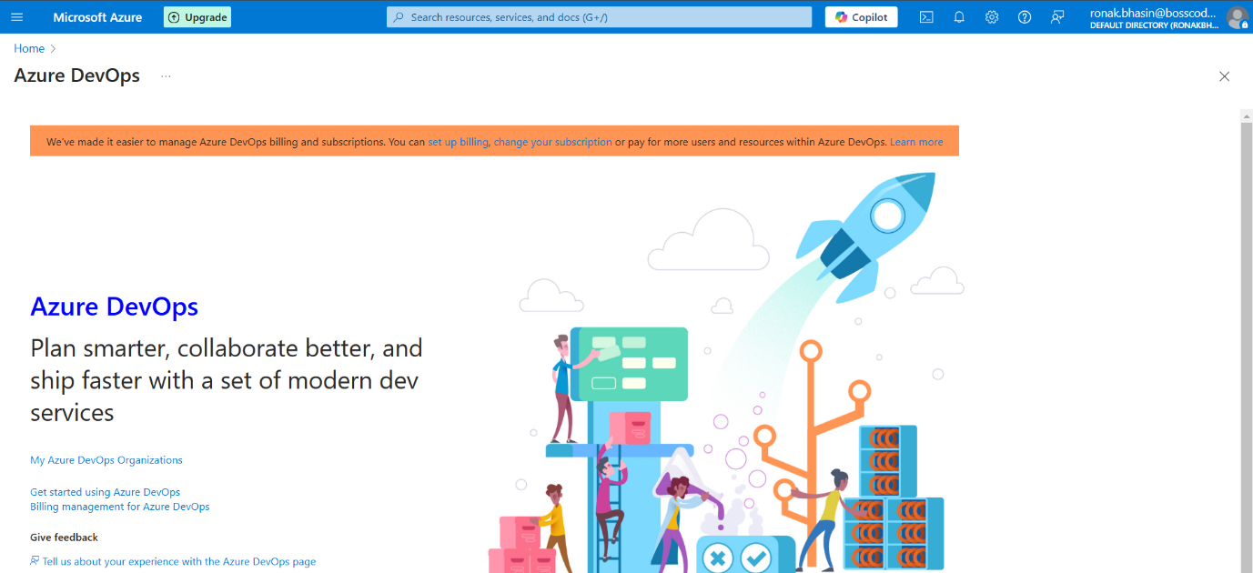
Step 2: Then, click on Get Started using Azure DevOps, then this page will open.
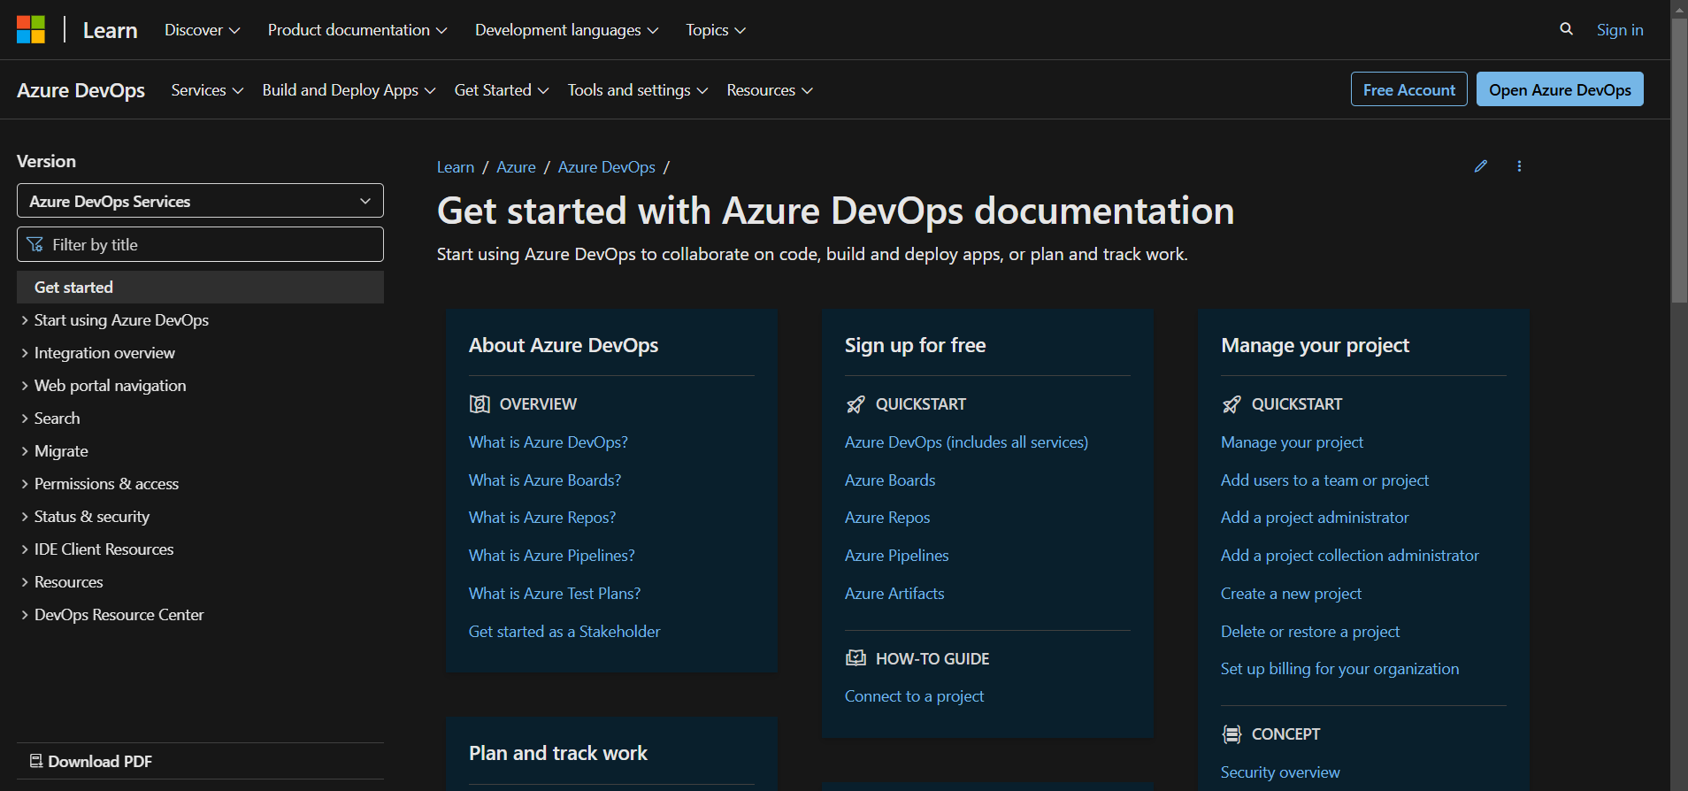
Step 3: Then, login using your Microsoft account by entering all the required details, by this you are creating an organization, you can create multiple organisations.
Step 4: Now, go to this link for stating Azure DevOps.
https://app.vsaex.visualstudio.com/signup/?acquisitionId=51b1be59-3895-4596-9702-a637909fb87c&campaign=o~msft~profile~lifecyclemail_service_attach&mkt=en-us&acquisitionType=byDefault
OR
You can search Azure DevOps on the Azure portal and go to My Azure DevOps organisation.
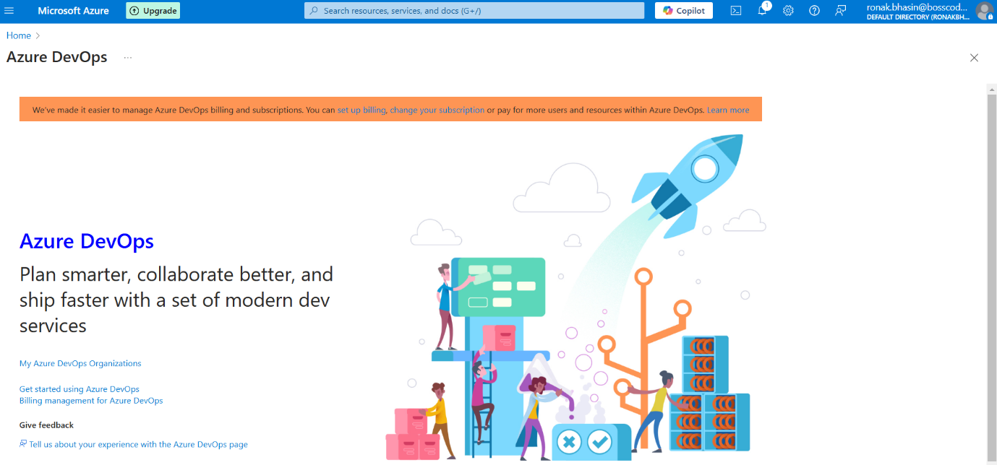
Step 5: Now, you will be able to see the homepage of your Azure DevOps homepage from where you can create pipelines or anything else.
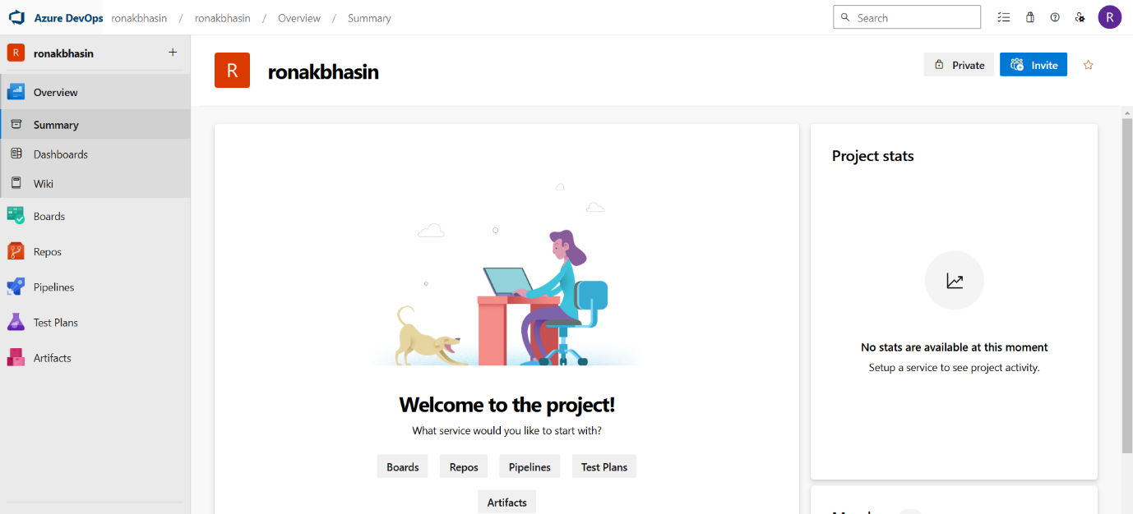
Azure DevOps Services:
Azure DevOps consists of five key services:
a) Azure Repos (Version Control)
- A Git-based repository for source code management.
- Supports both Git and TFVC (Team Foundation Version Control).
- Features:
  - Branching & Merging
  - Code reviews & Pull requests
  - Integration with Azure Pipelines
b) Azure Pipelines (CI/CD Automation)
- Automates build, test, and deployment processes.
- Supports Multi-stage Pipelines for CI/CD.
- Can integrate with:
  - Containers (Docker, Kubernetes)
  - Cloud services (Azure, AWS, GCP)
  - Testing tools (Selenium, JUnit)
c) Azure Boards (Agile Project Management)
- Helps in managing projects using Kanban, Scrum, and Agile methodologies.
- Features:
  - Work tracking (Tasks, Bugs, Features)
  - Dashboards & Reporting
  - Integration with GitHub and Azure Repos
d) Azure Test Plans (Testing & QA)
- Provides manual & automated testing tools.
- Features:
  - Load testing, Exploratory testing
  - Integration with Selenium, JMeter, Appium
  - Bug tracking and reporting
e) Azure Artifacts (Package Management)
- Allows storing, sharing, and managing packages and dependencies.
- Supports:
  - NuGet, npm, Maven, Python, and Universal Packages
  - Integration with CI/CD Pipelines
Continuous Integration & Continuous Deployment (CI/CD):
1. Continuous Integration (CI):
- Automates code building, testing, and integration.
- Every code commit triggers:
  - Automated build
  - Unit tests
  - Code analysis
2. Continuous Deployment (CD):
- Automates release and deployment of applications.
- Ensures faster delivery with minimal manual intervention.
- Supports:
  - Blue-Green Deployments
  - Canary Releases
  - Rolling Updates
CI/CD Workflow:
- The developer commits code to Azure Repos/GitHub.
- Azure Pipelines triggers CI process:
  - Builds the application
  - Runs automated tests
- CD pipeline deploys the application to:
  - Azure Kubernetes Service (AKS)
  - Azure App Service
  - Virtual Machines (VMs)
Azure DevOps CI/CD Pipeline:
Step 1: Open the Azure DevOps window and from the left-side bar, first go to Pipelines and then select Environments from it and then click on Create Environment.
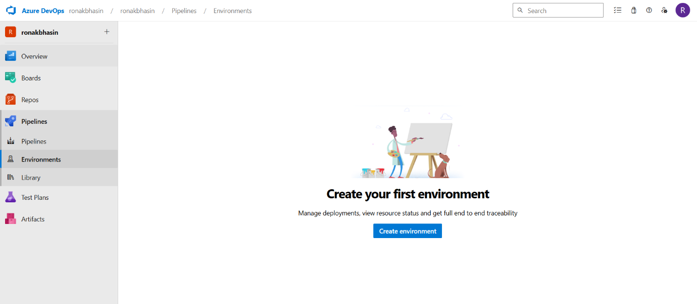
Step 2: Now, enter the name of Environment and enter the description and select Resource.
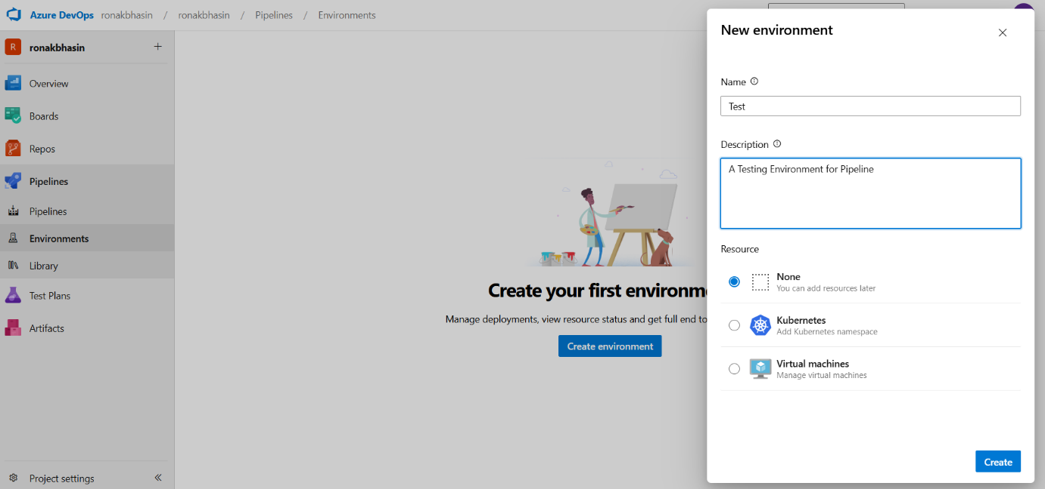
Step 3: Now, if you want to create from some other organization, you can create a new organization, else you can create in this organisation also.
Step 4: Now, go to the Project settings and select Service Connections and you will find the list if there are any created already.
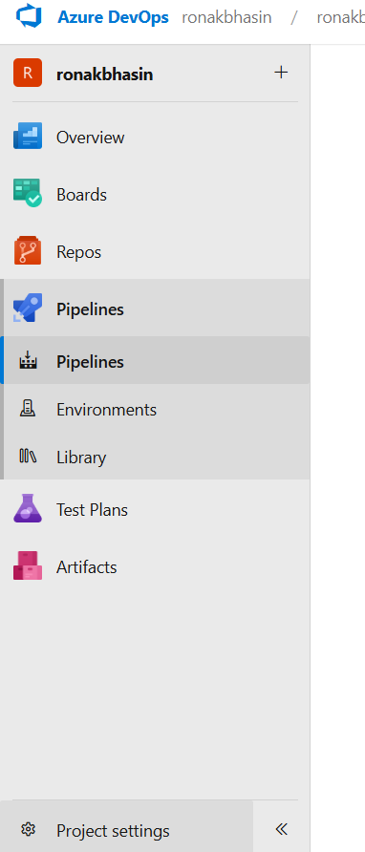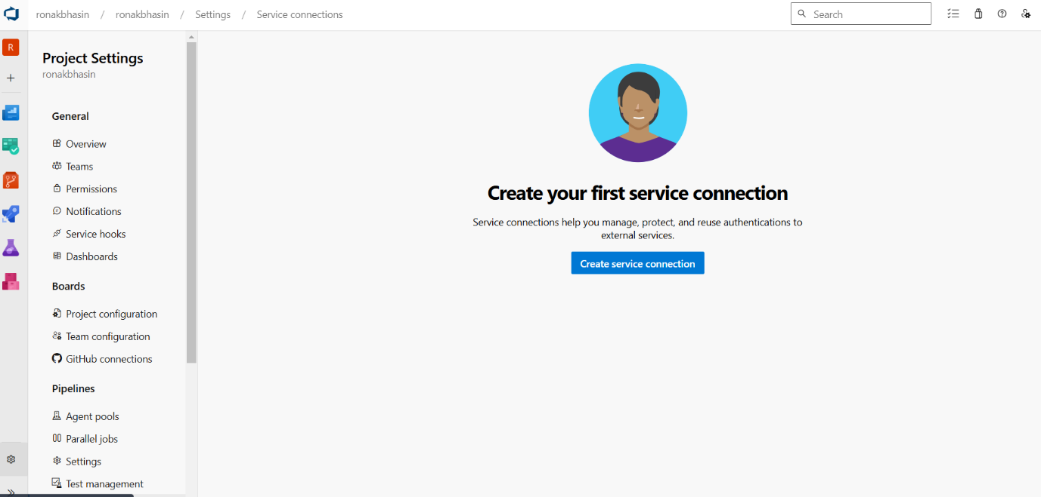
Step 5: Now, click on Create Service Connection.
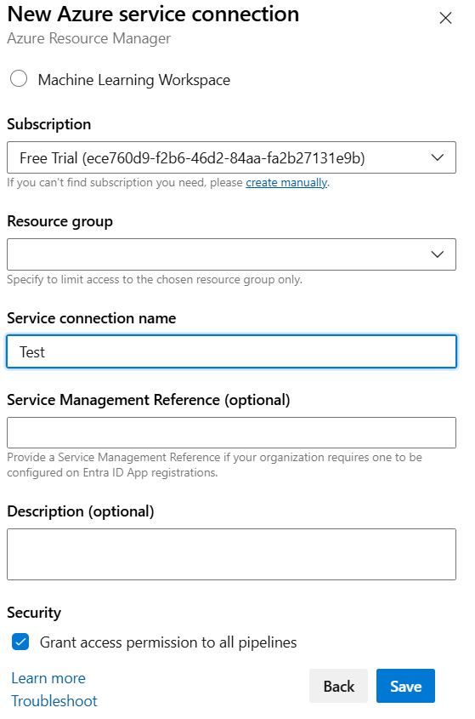
Step 6: Now, you can check the Service connection.
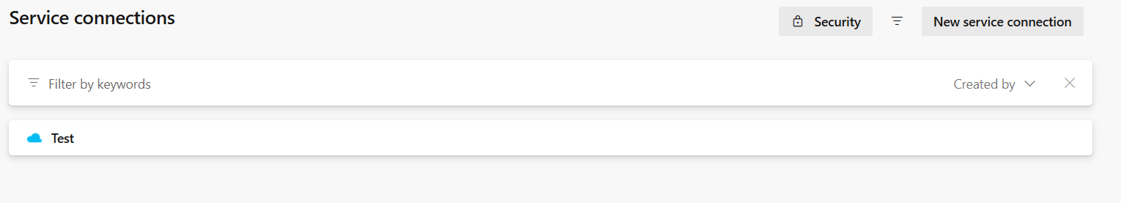
Step 7: Now, to create Repose, go to Repos and then select Files.
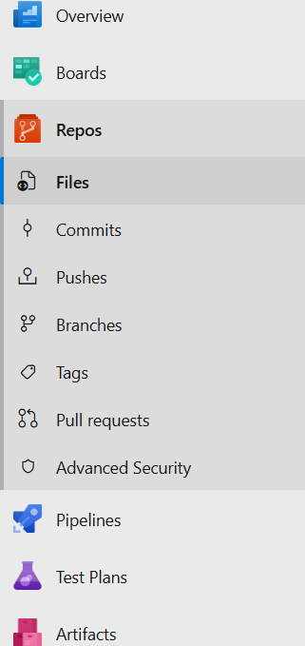
Step 8: Go to Create New Repository and then create by selecting the type and entering the name.
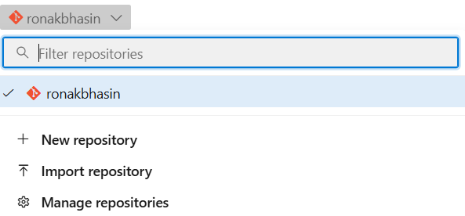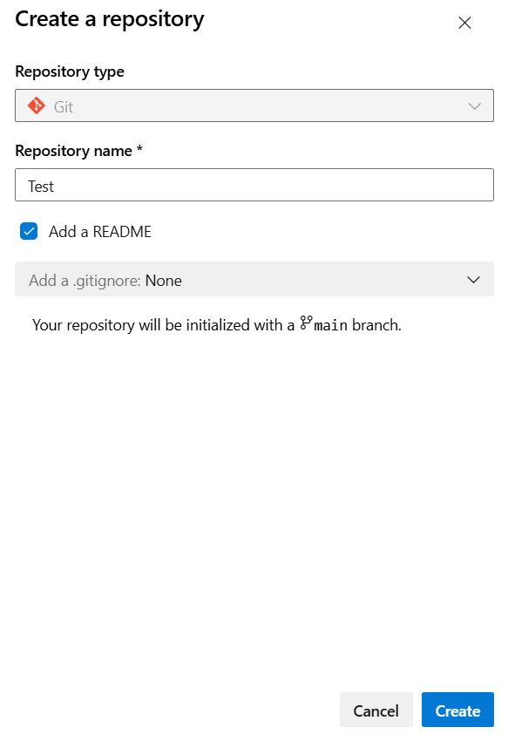
Step 9: Now, the Repo is created
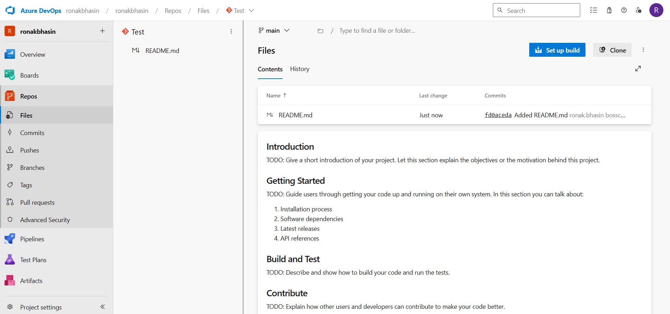
Step 10: Now, go to the Pipeline and Under Connect section, select Azure Repos Git.
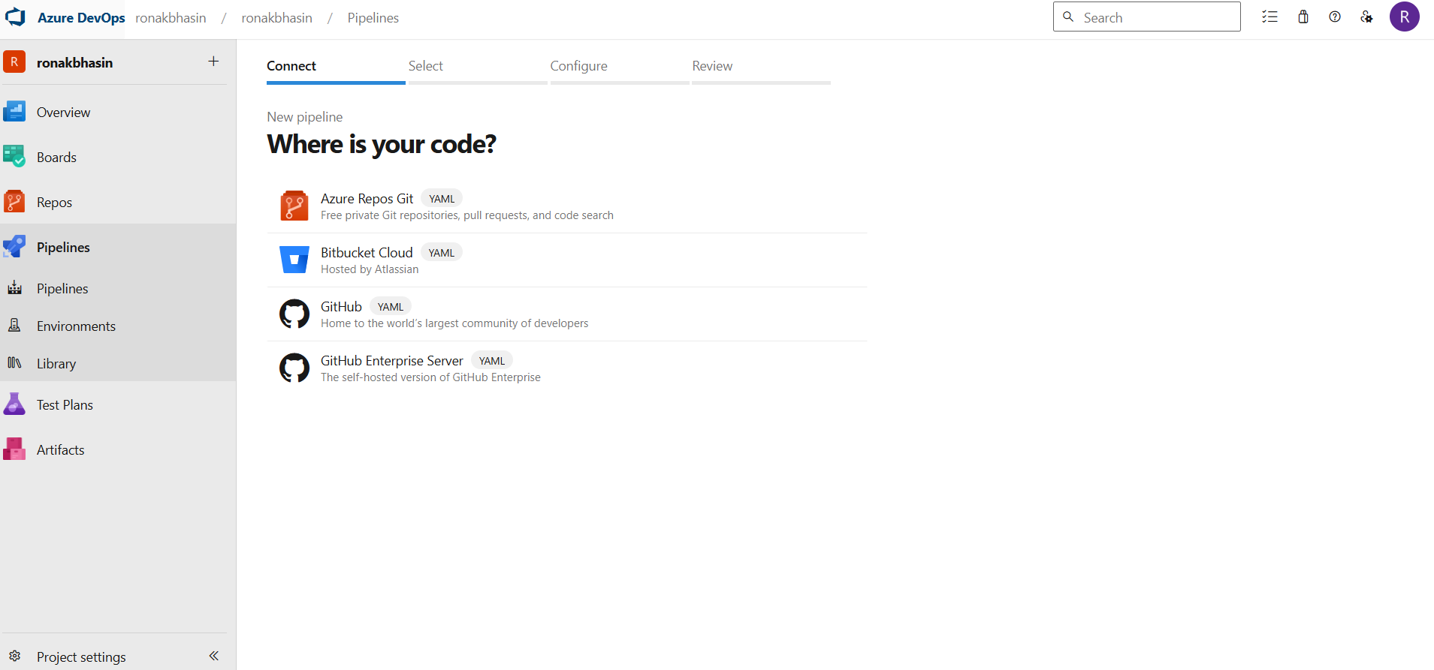
Step 11: Then, under the Select section select Test.
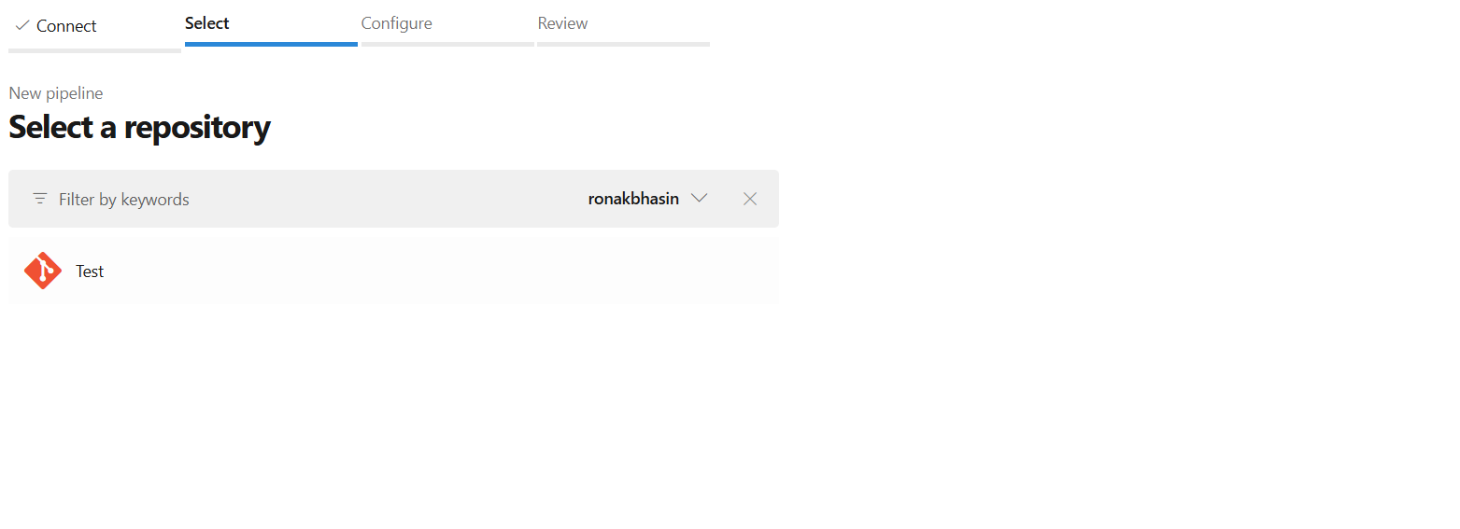
Step 12: Then, under the Configure section, select .NET Core Function App.
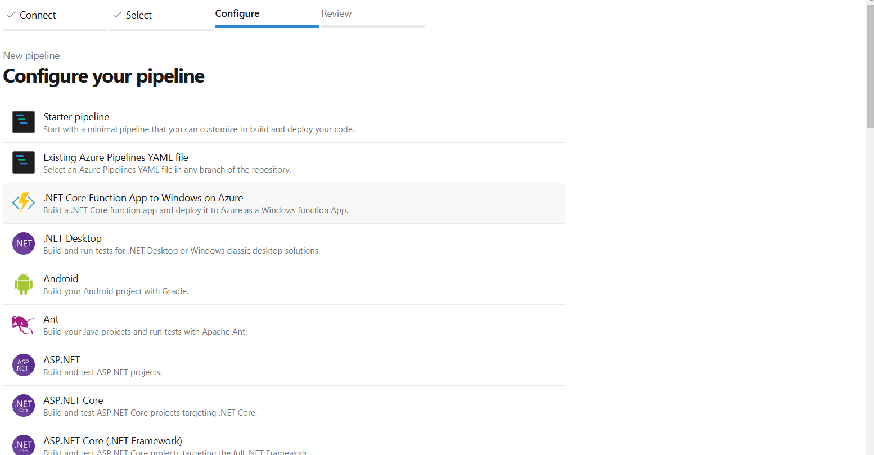
Step 13: Then, Review and Run.
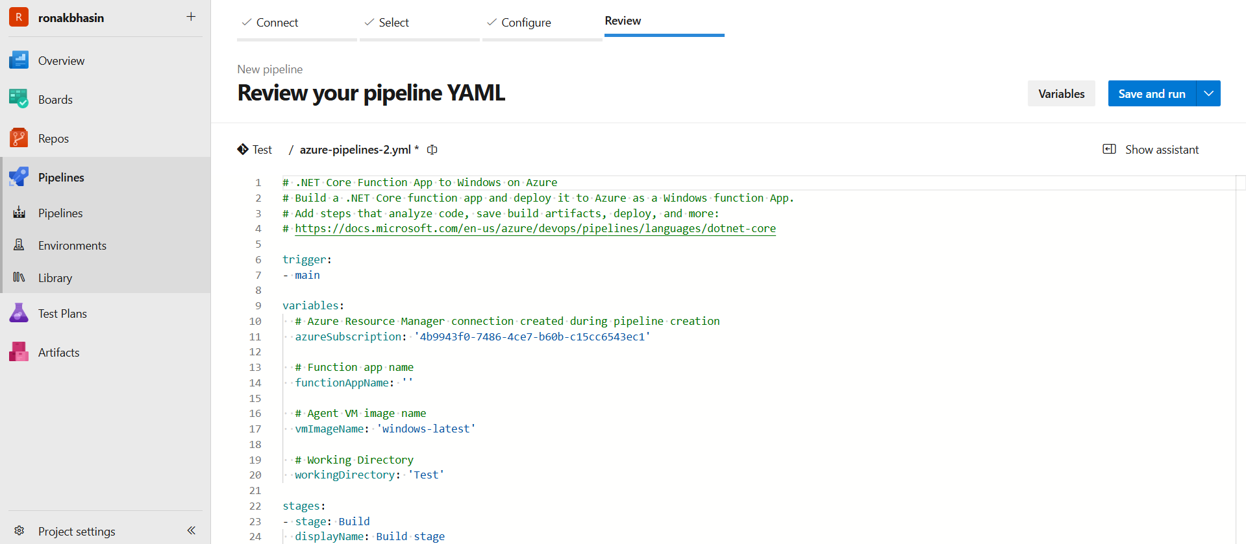
Step 14: Then, the Pipeline will run and appear like this.
Azure Monitoring and Log Analytics:
Introduction to Azure Monitoring:
Azure Monitor is a comprehensive monitoring solution for collecting, analyzing, and responding to telemetry data from applications, infrastructure, and networks. It helps ensure high availability, performance, and security of Azure and hybrid environments.
Why Use Azure Monitoring?
1. Proactively detects issues before they impact users.2. Provides real-time metrics and logs for troubleshooting.3. Supports automated alerts and actions.4. Integrates with other Azure services like Security Center, Application Insights, and Sentinel.
Key Components of Azure Monitor:
1. Metrics – Numerical data from Azure resources (e.g., CPU, memory usage).
2. Logs – Detailed event logs for in-depth analysis.
3. Alerts – Notifications when specific conditions are met.
4. Dashboards – Custom views of collected data.
5. Application Insights – Monitors application performance.
6. Log Analytics – Query and analyze log data.
7. Azure Sentinel – SIEM (Security Information and Event Management) for threat detection.
Azure Monitor Architecture:
1. Data Collection:
Collects telemetry data from various sources (Azure VMs, Kubernetes, databases, etc.).
2. Data Storage:
Stores logs and metrics in a centralized repository.
3. Data Analysis:
Uses AI/ML-driven insights for problem detection.
4. Actions & Notifications:
Sends alerts and triggers automation workflows.
Log Analytics in Azure Monitor:
Log Analytics is a feature of Azure Monitor that collects, analyzes, and visualizes log data from Azure resources, VMs, and applications. It helps in troubleshooting, auditing, and security analysis.
Why Use Log Analytics?
1. Helps in troubleshooting by querying logs.2. Provides centralized logging for Azure and on-prem resources.3. Enables security auditing and compliance monitoring.4. Supports custom queries using Kusto Query Language (KQL).
How to Set Up Log Analytics in Azure:
Step 1: Create a Log Analytics Workspace
- Go to Azure Portal → Search for Log Analytics Workspaces.
- Click Create → Select Subscription & Resource Group.
- Provide a unique name for the workspace.
- Select the Region closest to your resources.
- Click Review + Create → Create.
Step 2: Configure Data Sources
- Open the created Log Analytics Workspace.
- Navigate to Data Sources → Select resources (e.g., VMs, Kubernetes, Storage Accounts).
- Click Enable Monitoring to start data collection.
Step 3: Use Kusto Query Language (KQL) to Analyze Logs
Example query to check failed login attempts:
SecurityEvent
| where EventID == 4625
| project TimeGenerated, Account, Computer, EventSourceName
| order by TimeGenerated desc
KQL allows filtering, sorting, and aggregating log data efficiently.
Azure Monitor Alerts:
Azure Alerts notify users about critical events, such as high CPU usage, security threats, or application failures.
Types of Alerts:
- Metric Alerts – Triggered by metrics exceeding thresholds (e.g., CPU > 80%).
- Log Alerts – Triggered by log queries (e.g., failed login attempts).
- Activity Log Alerts – Triggered by Azure resource changes (e.g., VM restart).
- Prometheus Alerts – Used for Kubernetes monitoring.
How to Create an Alert:
- Go to Azure Monitor → Click Alerts.
- Click New Alert Rule.
- Select Resource (e.g., VM, Database).
- Define Condition (e.g., CPU > 80%).
- Set Action Group (email, SMS, webhook).
- Click Create Alert Rule.
Azure Monitor Dashboards:
Dashboards allow users to visualize monitoring data using graphs, charts, and reports.
Steps to Create a Dashboard:
- Open Azure Portal → Go to Azure Monitor.
- Click Dashboards → New Dashboard.
- Add widgets (Graphs, Metrics, Logs).
- Save and Share with the team.
Best Practices for Azure Monitoring:
1. Enable Monitoring at Scale – Use Azure Policy to apply monitoring settings across all resources.2. Use Log Analytics – Regularly analyze logs for performance and security insights.3. Set Alerts & Auto-healing – Automate responses to failures using Azure Functions.4. Monitor Costs – Track usage and optimize spending using Azure Cost Management.5. Use Workbooks – Create detailed reports combining metrics, logs, and queries.
Azure Load Balancer:
Azure Load Balancer is a Layer 4 (Transport Layer) service that distributes incoming network traffic across multiple servers (VMs) to ensure high availability, reliability, and scalability of applications.
Key Features:
- High Availability: Ensures applications remain available even if a server fails.
- Scalability: Distributes traffic efficiently across backend instances.
- Health Probing: Automatically detects and removes unhealthy instances.
- Low Latency: Uses a high-performance software-defined networking (SDN) infrastructure.
- Integration: Works with Azure Virtual Machines (VMs), Virtual Machine Scale Sets, and Availability Sets.
Types of Azure Load Balancers:
Load Balancer Type | Purpose | Use Case
Public Load Balancer | Distributes internet-facing traffic across VMs in Azure. | Host web applications, APIs, and services with external users.
Internal Load Balancer (ILB) | Distributes traffic within a private network (VNet). | Load balancing within an intranet, private applications, or databases.
Gateway Load Balancer | Integrates with firewalls, IDS/IPS, and security appliances. | Used for advanced security filtering before reaching VMs.
How Azure Load Balancer Works:
Azure Load Balancer operates at Layer 4 (Transport Layer) and supports TCP, UDP, and HTTP/HTTPS protocols.
Components of Azure Load Balancer:
1. Frontend IP Configuration:
- Defines the IP address that clients connect to.
- Can be Public (Internet-facing) or Private (Internal ILB).
2. Backend Pool:
- A group of Virtual Machines (VMs) that receive traffic.
- Can be VMs, VM Scale Sets, or Availability Sets.
3. Load Balancing Rules:
- Defines how traffic is distributed among backend VMs.
- Supports port-based routing (e.g., HTTP on port 80, HTTPS on port 443).
4. Health Probes:
- Monitors the health of backend VMs and removes unhealthy instances.
- Checks TCP, HTTP, or HTTPS endpoints.
5. Outbound Rules (SNAT - Source Network Address Translation)
- Allows backend VMs to initiate outbound internet connections.
- Uses the public frontend IP for outgoing requests.
Steps to Implement Azure Load Balancer:
Step 1: Create a Public Load Balancer
1. Go to Azure Portal → Search for Load Balancer → Click Create.2. Select Subscription & Resource Group.3. Name: MyPublicLoadBalancer.4. Region: Select the same region as your VMs.5. Type: Choose Public (for internet-facing applications).6. SKU: Choose Standard (supports availability zones & security features).7. Frontend IP Configuration: Create a new Public IP Address.8. Click Review + Create → Then Create.
Step 2: Configure Backend Pool
1. Open the created Load Balancer.2. Click on Backend Pools → Click + Add.3. Name: BackendPool1.4. Choose Virtual Machines and add the existing VMs.5. Click Add.
Step 3: Create Health Probe
1️. Go to Health Probes → Click + Add.2. Name: HealthProbe1.3. Protocol: Choose HTTP / TCP.4. Port: 80 (for web applications).5. Interval: 5 seconds, Unhealthy threshold: 2.6. Click OK.
Step 4: Create Load Balancing Rules
1. Go to Load Balancing Rules → Click + Add.2. Name: LB-Rule-80.3. Frontend IP: Select Frontend Public IP.4. Backend Pool: Select BackendPool1.5. Protocol: TCP, Port: 80.6. Session Persistence: Choose None or Client IP (to keep sessions).7. Click OK.
Step 5: Testing the Load Balancer
1. Deploy a Web App (Install Nginx or IIS on VMs).2. Get Public IP of the Load Balancer from Azure Portal.3. Open a browser → Enter Load Balancer IP → Should see a webpage served from one of the VMs.4. Stop one VM → Load Balancer should automatically redirect traffic to the healthy VM.

